**PRACTICAL 1**

**QUESTION-A:**What is the probability of having 2 girl babies out of 3 babies?

**QUESTION-B:**What is the probability of having more than 2 girl babies out of 3 babies?

**OBJECTIVE-A:** To find the probability of having 2 girl babies out of 3 babies using Binomial Distribution.

**FORMULA USED:** BINOM.DIST(number_ s, trial, probability_ s, cumulative)

**PROCEDURE:**

1. Define:

total no of trials (n) = 3, no. of success (girl babies) (x) = 2 and probability of success (p) = 0.5.

1. Find the required probability i.e., P(X=x) using the above-mentioned Binomial function formula.
2. To compute probability mass function, select FALSE in cumulative.
3. Required result is obtained.

**RESULT:**

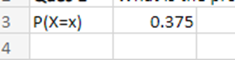

**CONCLUSION:** The probability of having 2 girl babies out of 3 babies is 0.375.

**OBJECTIVE-B:** To find the probability of having more than 2 girl babies out of 3 babies using Binomial Distribution.

**FORMULA USED:** BINOM.DIST(number_ s, trial, probability_ s, cumulative)

**PROCEDURE:**

1. Define:

total no of trials (n) = 3, no. of success (girl babies) (x) > 2 and probability of success (p) = 0.5.

1. Find the required probability i.e., P (X > x) = 1 – P (X <= x).
2. To compute cumulative function, select TRUE in cumulative to find P (X <= x).
3. Required result is obtained.

**RESULT:**

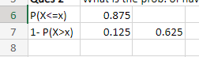

**CONCLUSION:** The probability of having more than 2 girl babies out of 3 babies is 0.125.

**PRACTICAL 2**

**QUESTION:** In a class student grade for a single exam follows beta distribution with parameter with alpha = 8.28 and beta = 3.16. What is the probability that student is below the mean?

**OBJECTIVE:** To find the probability that student grade is below the mean using Beta Distribution.

**FORMULA USED:**

1. Mean: alpha/alpha + beta
2. Variance: alpha*beta/ (alpha + beta) ^2 * (alpha+beta+1)
3. BETA.DIST(x, alpha, beta, commutative)

**PROCEDURE:**

1. Compute the mean for the given information using above formula.
2. Define:

x = mean value, alpha = 8.28 and beta = 3.16.

1. Find the required probability i.e., P (alpha, beta, X< 0.72).
2. To compute cumulative function, select TRUE in cumulative to find P (X >x).
3. Required result is obtained.

**RESULT:**



**CONCLUSION:**Average of student grade = 0.72 and the probability that the student is below mean is 0.462.

**PRACTICAL 3**

**QUESTION:** Consider a dataset-

**DATASET:**

|  |  |  |  |  |  |  |  |
| --- | --- | --- | --- | --- | --- | --- | --- |
| **PATIENT ID** | **PINCODE** | **AGE (Yrs.)** | **GENDER** | **HEIGHT (cm)** | **WEIGHT (Kg)** | **SES** | **SBP (mmHg)** |
| ABC01 | 201304 | 25 | M | 151 | 80 | Low | 130 |
| ABC02 | 201304 | 28 | M | 156 | 81 | Low | 135 |
| ABC03 | 201304 | 28 | M | 156 | 85 | Low | 110 |
| ABC04 | 201305 | 27 | F | 154 | 90 | Medium | 120 |
| ABC05 | 201305 | 25 | F | 157 | 79 | Medium | 160 |
| ABC06 | 201305 | 28 | F | 150 | 80 | Medium | 140 |
| ABC07 | 201304 | 28 | F | 151 | 82 | Medium | 115 |
| ABC08 | 201305 | 30 | F | 152 | 65 | High | 110 |
| ABC09 | 201304 | 31 | M | 158 | 54 | High | 112 |
| ABC10 | 201305 | 31 | M | 162 | 60 | High | 115 |
| ABC11 | 201305 | 34 | F | 157 | 60 | High | 121 |
| ABC12 | 201305 | 34 | M | 158 | 65 | Medium | 125 |

1. Define the data for each of the characteristics under study.
2. Compute appropriate measures of central tendency along with dispersion for each variable.
3. Is there any outlier in Height, Weight and SBP?
4. What will be the average height of males and females separately?
5. Generate a new variable called as BMI (Body Mass Index) and perform descriptive statistics on it.

**OBJECTIVE:**To answer the given set of questions using the data table.

**RESULT:**

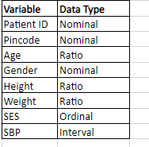

**FORMULA USED:**

1. AVERAGE (range)
2. MODE (range)
3. MIN (range)
4. MAX (range)
5. RANGE = MAX - MIN
6. QUARTILE (range, 1)
7. QUARTILE (range, 3)
8. INTER QUARTILE RANGE = Q3 – Q1
9. PERCENTAGE for categorical data.
10. VAR.S(range)
11. STDEV.S(range)

**PROCEDURE:**

1. Assign values to the categorical variables for calculations such as, in case of Gender: M=1 and F=2 and in SES: LOW=1, MEDIUM=2 and HIGH=3.
2. Compute the measures of central tendency and measures of dispersion using above formulae.
3. For categorical data calculate mode and percentage as a measure of central tendency and dispersion.

**RESULT:**

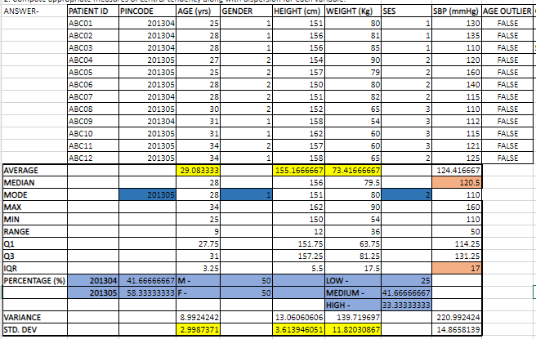

**CONCLUSION:**The highlighted cells represents the suitable measure of central tendency and measure of dispersion for each of the given variable:

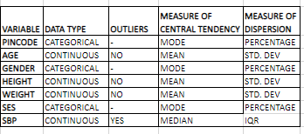

**FORMULA USED:**

1. Upper Bound = Q3 + (1.5*IQR)
2. Lower Bound = Q1 - (1.5*IQR)
3. OUTLIER = OR(value>upper bound, value<lower bound)

**PROCEDURE:**

1. Compute the upper and lower bounds for the Height, Weight and SBP data.
2. Using the above formula find the outliers for each variable and value.
3. If the answer is “FALSE” means outlier is not present and if the answer is “TRUE” means outlier is present in the data.

**RESULT:**

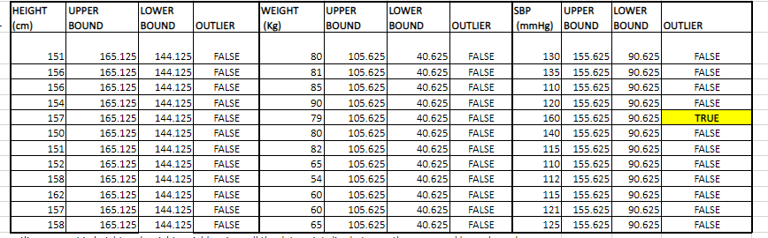

**CONCLUSION:**There are no outliers present in Height and Weight variables since all the data points lies between the upper and lower bound. In SBP one observation is greater than upper bound i.e,160. Therefore, we can conclude that outlier is present in SBP.

**FORMULA USED:**AVERAGEIFS (average range, criteria range1, criteria1,)

**PROCEDURE:**

1. To calculate Average Height of Male use AVERAGEIFS function, then select height range, gender range as criteria range and “M” as criteria.
2. Follow the same steps to calculate Average Height of Female.

**RESULT:**



**FORMULA USED:**BMI = WEIGHT/(HEIGHT)^2 in {KG/(M)^2}

**PROCEDURE:**

1. Convert Height (cm) into Height (m) to calculate BMI.
2. Compute BMI for each value using above formula.
3. Also, compute descriptive statistics.

**RESULT:**

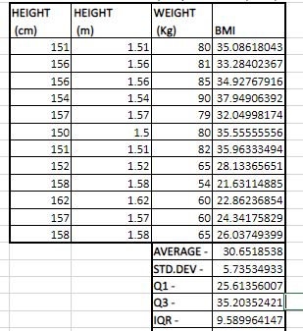

**PRACTICAL 4**

**QUESTION:** Vizualise the given dataset as per your choice of graphs.

**DATASET:**

|  |  |  |  |  |  |  |  |
| --- | --- | --- | --- | --- | --- | --- | --- |
| **PATIENT ID** | **PINCODE** | **AGE (Yrs.)** | **GENDER** | **HEIGHT (cm)** | **WEIGHT (Kg)** | **SES** | **SBP (mmHg)** |
| ABC01 | 201304 | 25 | M | 151 | 80 | Low | 130 |
| ABC02 | 201304 | 28 | M | 156 | 81 | Low | 135 |
| ABC03 | 201304 | 28 | M | 156 | 85 | Low | 110 |
| ABC04 | 201305 | 27 | F | 154 | 90 | Medium | 120 |
| ABC05 | 201305 | 25 | F | 157 | 79 | Medium | 160 |
| ABC06 | 201305 | 28 | F | 150 | 80 | Medium | 140 |
| ABC07 | 201304 | 28 | F | 151 | 82 | Medium | 115 |
| ABC08 | 201305 | 30 | F | 152 | 65 | High | 110 |
| ABC09 | 201304 | 31 | M | 158 | 54 | High | 112 |
| ABC10 | 201305 | 31 | M | 162 | 60 | High | 115 |
| ABC11 | 201305 | 34 | F | 157 | 60 | High | 121 |
| ABC12 | 201305 | 34 | M | 158 | 65 | Medium | 125 |

**OBJECTIVE:** To perform graphical representation on the given dataset.

**FORMULA USED:** INSERT > RECOMMENDED CHARTS.

**PROCEDURE:**

1. Select the cell of the data to obtain the required charts.
2. Click on "Insert" tab in the Excel ribbon at the top of the screen.
3. Click on the "Charts" group to see various chart types available in Excel. Select the chart type that best suits the data.
4. Customize Chart Elements by right clicking on the chart obtained.
5. Go to format and edit information like “Chart Title”, “Axis Labels”, “Data Labels”, color, fonts, gridlines and more.

**RESULT:**

|  |  |  |
| --- | --- | --- |
| 1. **RELATIONSHIP BETWEEN HEIGHT (cm) AND WEIGHT (Kg)** | 1. **RELATIIONSHIP BETWEEN WEIGHT (Kg) AND SBP (mmHg)** | |
| 1. **RELATIONSHIP BETWEEN AGE (Yrs.) AND SBP (mmHg)** | 1. **GRAPGICAL VISUALIZATION OF SBP (mmHg)** | |
| 1. **COMPOSITION OF SOCIAL ECONOMIC STATUS** | 1. **DISTRIBUTION OF AGE (Yrs.) AMONG MALES AND FEMALES** |
| 1. **DISTRIBUTION OF HEIGHT (cm)** | 1. **DISTRIBUTION OF WEIGHT (Kg)** |

**PRACTICAL 5**

**QUESTION:** Compute Skewness and Kurtosis of the data and comment on the findings.

DATASET:

|  |  |
| --- | --- |
| **AGE**  **(In yrs.)** |  |
| 35 | 21 |
| 24 | 24 |
| 27 | 28 |
| 25 | 44 |
| 28 | 31 |
| 29 | 22 |
| 19 | 44 |
| 29 | 39 |
| 27 | 29 |
| 35 | 33 |

**OBJECTIVE:** To compute Skewness and Kurtosis for the given data.

**FORMULA USED:**

1. SKEW (number1, [number2], ….)
2. KURT (number1, [number2], ….)

**PROCEDURE:**

1. Use the function SKEW and select the range of the dataset.
2. Click ok and get the output.
3. Similarly, Use the function KURT and select the range of the dataset.
4. Click ok and get the output.

**RESULT:**

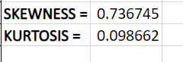

**CONCLUSION:**

1. Skewness measures the asymmetry of a data distribution.

Since, the value of skewness is 0.74. It is positively skewed indicating a right-skewed distribution with a long right tail.

1. Kurtosis measures the tailedness or peakedness of a data distribution.

Since, its value is 0.099 <3 indicates that the data distribution is platykurtic i.e., the data has lighter tails and fewer extreme values than a normal distribution.

**PRACTICAL 6**

**QUESTION:**In the given dataset annual profit in Indian rupees is given for 50 individuals. Perform suitable Descriptive Analysis on annual profit and comment on it.

**DATASET:**

|  |  |  |  |  |
| --- | --- | --- | --- | --- |
| **ANNUAL PROFIT (Rs)** |  |  |  |  |
| 6333 | 8760 | 7659 | 8456 | 9642 |
| 7097 | 8755 | 3146 | 6545 | 8161 |
| 4904 | 9255 | 2638 | 7098 | 9390 |
| 3020 | 8240 | 2944 | 9943 | 3456 |
| 6269 | 9941 | 9452 | 9482 | 9534 |
| 6801 | 2841 | 5144 | 4043 | 7384 |
| 8476 | 9659 | 6952 | 7656 | 4039 |
| 2741 | 3218 | 4349 | 6472 | 5798 |
| 4661 | 4993 | 4143 | 8030 | 3385 |
| 8353 | 6872 | 5364 | 4275 | 9990 |

**OBJECTIVE:** To perform Descriptive Analysis on Annual Profit (Rs).

**FORMULA USED:**

1. HOME > ADD-INS > TOOLPAK > DESCRIPTIVE STATISTICS
2. INSERT > RECOMMENDED CHARTS > HISTOGRAM

**PROCEDURE:**

1. Using the above step go to Descriptive Statistics and select the Input range.
2. Then, select the output range and tick label, summary statistics, confidence interval for mean at 95%.
3. Click on Ok.
4. Similarly, for Histogram, go to recommended charts and select the histogram.
5. Customize Chart Elements by right clicking on the chart obtained.
6. Go to format and edit information like “Chart Title”, “Axis Labels”, “Data Labels”, “Bins Width”, color, fonts, gridlines and more.

**RESULT:**

**DISCRIPTIVE STATISTICS**

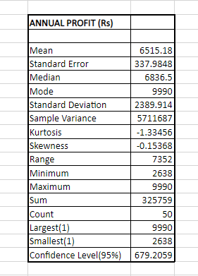

**GRAPHICAL REPRESENTATION**

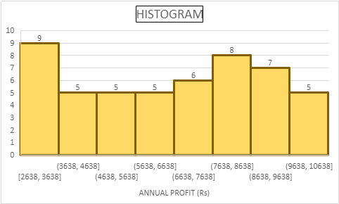

**CONCLUSION:**

1. Through the Descriptive Analysis we can conclude the following details:

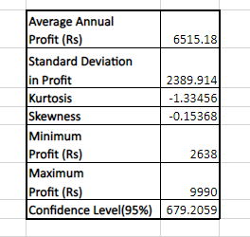

1. Since Mean < Median < Mode, the data is not normally distributed.
2. Through histogram we can say that maximum no. of individuals i.e., 9 have the annual profit between Rs 2638-3638 followed by 8 individuals having profit between Rs 7638-8638 and so on.

**PRACTICAL 7**

**QUESTION:**Based on the given data set test the hypothesis that sample mean is equal to population mean of 100.

**DATASET:**

|  |
| --- |
| **DATA POINTS** |
| 70 |
| 120 |
| 110 |
| 101 |
| 88 |
| 83 |
| 95 |
| 98 |
| 107 |
| 100 |

**OBJECTIVE:**

H0: There is no significant difference between hypothetical mean and sample mean i.e., µ= 100

H1: There is a significant difference between hypothetical mean and sample mean i.e., µ≠ 100.

**FOEMULA USED:**

1. Sample Mean = AVERAGE ( )
2. Standard Deviation = STDEV.S ( )
3. No. of Observation = COUNT ( )
4. t statistics =

**PROCEDURE:**

1. Set up the Null Hypothesis H0.
2. Set up the Alternative Hypothesis H1.
3. Choose the appropriate level of significance (α) or p value.
4. Compute the test statistics using above formulae.
5. If calculated t < tabulated t value, accept H0 otherwise reject H0.

OR, if p value > 0.05, accept H0 otherwise reject.

**RESULT:**

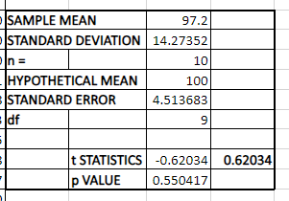

**CONCLUSION:** Since, p value (0.55) > 0.05, it is significant at 5%. Therefore, we accept H0 and conclude that µ = 100.

**PRACTICAL 8**

**QUESTION:**Weight of 10 participants is given as follows –

**DATASET:**

|  |
| --- |
| **WEIGHT (Kg)** |
| 70 |
| 67 |
| 62 |
| 68 |
| 61 |
| 68 |
| 70 |
| 64 |
| 64 |
| 66 |

Is the average weight of participants being 64 at 5% level of significance.

**OBJECTIVE:**

H0: There is no significant difference between the average weight of participants, i.e., µ= 64.

H1: There is a significant difference between the average weight of participants, i.e., µ≠ 64.

**FOEMULA USED:**

1. Sample Mean = AVERAGE ( )
2. Standard Deviation = STDEV.S ( )
3. No. of Observation = COUNT ( )
4. t statistics =

**PROCEDURE:**

1. Set up the Null Hypothesis H0.
2. Set up the Alternative Hypothesis H1.
3. Choose the 5% level of significance (α) or p value.
4. Compute the test statistics using above formulae.
5. If t calculated < t tabulated value, accept H0 otherwise reject H0.

OR, if p value > 0.05, accept H0 otherwise reject.

**RESULT:**

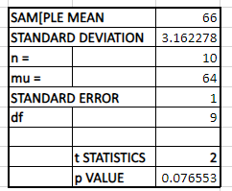

**CONCLUSION:** Since, p value (0.076553) > 0.05, it is significant at 5%. Therefore, we accept H0 and conclude that the average weight of participants is 64 Kg.

**PRACTICAL 9**

**QUESTION:**Maths score of two groups is given as follows. Is average score of two groups are same.

**DATASET:**

|  |  |
| --- | --- |
| **GROUP 1** | **GROUP 2** |
| 25 | 44 |
| 32 | 34 |
| 30 | 22 |
| 34 | 10 |
| 24 | 47 |
| 14 | 31 |
| 32 | 40 |
| 24 | 30 |
| 30 | 32 |
| 31 | 35 |
| 35 | 18 |
| 25 | 21 |
|  | 35 |
|  | 29 |
|  | 22 |

**OBJECTIVE:**

H0: There is no significant difference between the average maths score of two groups,

i.e., µ1 = µ2.

H1: There is a significant difference between the average maths score of two groups,

i.e., µ1 ≠ µ2.

FORMULA USED:

1. HOME > ADD INS > TOOL PAK > F TEST TWO SAMPLE FOR VARIANCE
2. HOME > ADD INS > TOOL PAK >t-TEST: TWO SAMPLE.

**PROCEDURE:**

1. Set up the Null Hypothesis H0.
2. Set up the Alternative Hypothesis H1.
3. Choose the appropriate level of significance (α) or p value.
4. Compute F test to test whether the sample variance is equal or not.
5. If calculated F < tabulated F value, accept H0 or p value > 0.05 and apply t-test two sample assuming equal variances.
6. If calculated F > tabulated F value, reject H0 and apply t-test two sample assuming unequal variances.
7. Conclude the results.

**RESULT:**

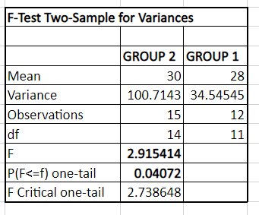

Since, p value < 0.05 at 5% level of significance. Therefore, we reject H0 and will compute

**t-TEST: TWO SAMPLE ASSUMING UNEQUAL VARIANCES.**

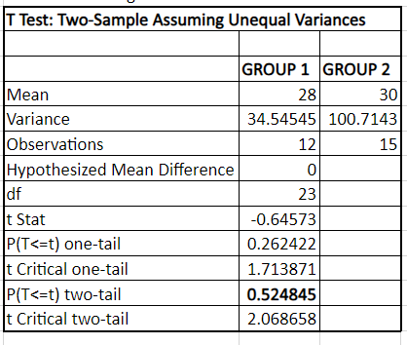

**CONCLUSION:** Since, p value (0.525) > 0.05 at 5% α. Therefore, we accept H0 and conclude that there is no significant difference between the average maths score of two groups,

i.e., µ1 = µ2.

PRACTICAL 10

**QUESTION:**Weight gain in Kg due to food A and food B is given as –

**DATASET:**

|  |  |
| --- | --- |
| **FOOD A** | **FOOD B** |
| 49 | 52 |
| 53 | 55 |
| 51 | 52 |
| 52 | 53 |
| 47 | 50 |
| 50 | 54 |
| 52 | 54 |
| 53 | 53 |

1. Assuming that 2 samples are independent. Test the hypothesis that weight gain due to food B is better than food A .
2. When same set of 8 animals were used for both food A and B then, test the same hypothesis.

**OBJECTIVE A:**

H0: There is no significant difference in weight gain due to food A and food B.

H1: Weight gains due to food B is better than food A.

**FORMULA USED:**

1. HOME > ADD INS > TOOL PAK > F TEST TWO SAMPLE FOR VARIANCE
2. HOME > ADD INS > TOOL PAK > t-TEST: TWO SAMPLE.

**PROCEDURE:**

1. Set up the Null Hypothesis H0.
2. Set up the Alternative Hypothesis H1.
3. Choose the appropriate level of significance (α) or p value.
4. Compute F test to test whether the sample variance is equal or not.
5. If calculated F < tabulated F value, accept H0 or p value > 0.05 and apply t-test two sample assuming equal variances.
6. If calculated F > tabulated F value, reject H0 and apply t-test two sample assuming unequal variances.
7. Conclude the results.

**RESULT:**

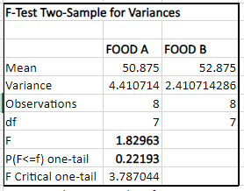

Since, p value (0.22)> 0.05 at 5% level of significance. Therefore, we accept H0 and will compute **t-TEST: TWO SAMPLE ASSUMING EQUAL VARIANCES.**

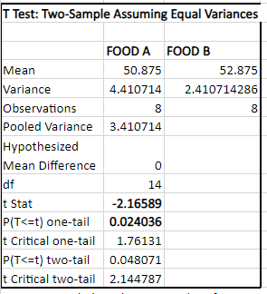

**CONCLUSION:** Since, p value (0.0240) <0.05 at 5% α. Therefore, we reject H0 and conclude that weight gain due to food B is better than food A.

**OBJECTIVE B:**

H0: There is no significant difference in weight gain due to food A and food B.

H1: Weight gains due to food B is better than food A.

**FORMULA USED:**HOME > ADD INS > TOOL PAK > t-TEST: PAIRED TWO SAMPLE FOR MEAN.

**PROCEDURE:**

1. Set up the Null Hypothesis H0.
2. Set up the Alternative Hypothesis H1.
3. Choose the appropriate level of significance (α) or p value.
4. Compute t statistics for paired sample.
5. If calculated t< tabulated t value, accept H0 otherwise reject H0.

OR, if p value > 0.05, accept H0 otherwise reject.

**RESULT:**

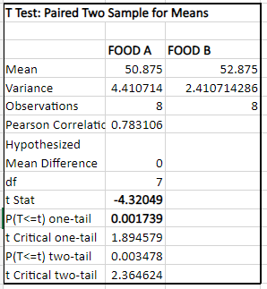

**CONCLUSION:** Since, p value (0.0240) < 0.05 at 5% α. Therefore, we reject H0 and conclude that weight gain due to food B is better than food A.

**PRACTICAL 11**

**QUESTION:** Serum Cholesterol level of 12 patients before and after giving drugs are as follows –

**DATASET:**

|  |  |
| --- | --- |
| **AFTER** | **BEFORE** |
| 201 | 200 |
| 231 | 236 |
| 221 | 216 |
| 260 | 233 |
| 228 | 224 |
| 237 | 216 |
| 326 | 296 |
| 235 | 195 |
| 240 | 207 |
| 267 | 247 |
| 284 | 210 |
| 201 | 209 |

Can we assume that the mean cholesterol level before and after giving the drug is statistically highly significant. (Test for alpha = 5% and 1%)

**OBJECTIVE:**

H0:There is no significant difference between the mean cholesterol level before and after giving the drug.

H1: There is a significant difference between the mean cholesterol level before and after giving the drug.

**FORMULA USED:**HOME > ADD INS > TOOL PAK > t-TEST: PAIRED TWO SAMPLE FOR MEAN.

**PROCEDURE:**

1. Set up the Null Hypothesis H0.
2. Set up the Alternative Hypothesis H1.
3. Choose the level of significance (α) or p value at 5% and 1%.
4. Compute t statistics for paired sample.
5. If calculated t < tabulated t value, accept H0 otherwise reject H0.

OR, if p value > 0.05, accept H0 otherwise reject.

**RESULT:**

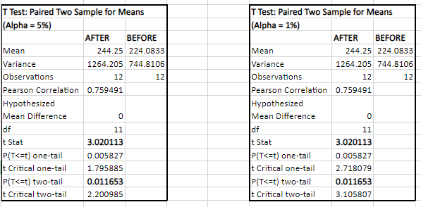

**CONCLUSION:**

* Since, p value (0.012) < 0.05 at 5% α. Therefore, we reject H0 and conclude that there is a significant difference between the mean cholesterol level before and after giving the drug.
* Since, p value (0.012) > 0.01 at 1% α. Therefore, we accept H0 and conclude that there is no significant difference between the mean cholesterol level before and after giving the drug.

**PRACTICAL 12**

**QUESTION:** Birth weight in Kg of babies born to women in particular hospital, classify according to their health status in table –

**DATASET:**

|  |  |  |
| --- | --- | --- |
| **HEALTH STATUS OF WOMEN** |  |  |
| **GOOD** | **FAIR** | **POOR** |
| 3.1 | 3 | 2.4 |
| 2.9 | 2.6 | 2.2 |
| 3.5 | 2.5 | 2 |
| 3.6 | 2.7 | 2.3 |
| 3.4 | 2.6 | 2.2 |
|  | 2.8 | 2.1 |
|  | 2.7 | 2 |
|  |  | 2.4 |
|  |  | 2.3 |
|  |  | 2.5 |

Test whether the mean birth weight of babies among the 3 groups of women are same or not? (Test for α = 5% and 1%)

**OBJECTIVE:**

H0: All the 3 groups of women have equal mean, i.e., µ1 = µ2 = µ3.

H1: At least on group have different mean, i.e., µ1 ≠ µ2 ≠ µ3.

**FORMULA USED:** HOME > ADD INS > TOOL PAK > ANOVA: SINGLE FACTOR.

**PROCEDURE:**

1. Set up the Null Hypothesis H0.
2. Set up the Alternative Hypothesis H1.
3. Choose the level of significance (α) or p value at 5% and 1%.
4. Compute F statistics using ANOVA table.
5. If calculated F < tabulated F value, accept H0 otherwise reject H0.

OR, if p value > 0.05, accept H0 otherwise reject.

1. In case H0 is rejected, perform STUDENT NEWMAN-KEULS TEST to find which group is significantly different.

**RESULT:**

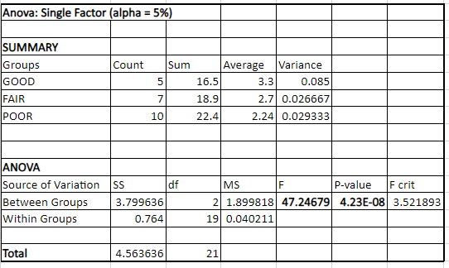

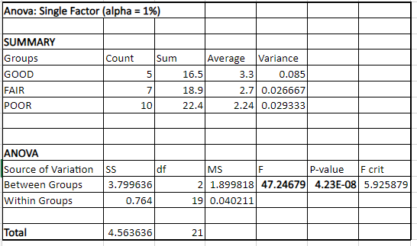

**CONCLUSION:**

* Since, p value < 0.05 at 5% α. Therefore, we reject H0 and conclude that at least on group of women have different mean, i.e., µ1 ≠ µ2 ≠ µ3.
* Also, p value < 0.01 at 1% α. Therefore, we reject H0 and conclude that at least on group of women have different mean, i.e., µ1 ≠ µ2 ≠ µ3.

In order to find which group of women have significantly different mean we will perform Multiple Comparison (POST HOE TEST)

**STUDENT NEWMAN-KEULS TEST (SNK TEST)**

Q1 = = **13.64867074**

Q2 = = **7.22669571**

Q3 = / Sqrt ((MSE /2) *(1/nA-1/nB) = **6.583055401**

**STANDARD STUDENT RANGE TABLE (AT ALPHA = 0.5)**

p = 3, q' = **3.593**

p = 2, q' = **2.96**

**CONCLUSION:**Based upon given data we have concluded that 3 group of women have different means in which Group A differ most significantly followed by Group B and C.

**PRACTICAL 13**

**QUESTION:**A study was conducted to investigate the effect of supplementary nutrition, a drag and placebo in increasing the weight of malnourished children. 15 malnourished children were randomly divided into 3 Groups A, B and C. Group A was given supplementary nutrition, group B the drug and group C the placebo. Gain in weight in these children was noted after 1 month of treatment. Results of the study are given in the table below.

Test whether the differences in weight gain on an average among the 3 groups are statistically significant or not at 5% level of significance. Also, test whether the differences between any 2 groups is statistically significant or not at 5% level of significance.

**DATASET:**

|  |  |  |
| --- | --- | --- |
| **GAININ WEIGHT (Kg)** |  |  |
| **A SUPPLEMENTARY** | **B DRUG** | **C PLACEBO** |
| 0.2 | 0.1 | 0.05 |
| 0.15 | 0.1 | 0.1 |
| 0.1 | 0.05 | 0.05 |
| 0.3 | 0.15 | 0.05 |
| 0.25 | 0.2 | 0.15 |

**OBJECTIVE:**

H0: All the 3 groups have equal mean, i.e., µ1 = µ2 = µ3.

H1: At least on group have different mean, i.e., µ1 ≠ µ2 ≠ µ3.

**FORMULA USED:** HOME > ADD INS > TOOL PAK > ANOVA: SINGLE FACTOR.

**PROCEDURE:**

1. Set up the Null Hypothesis H0.
2. Set up the Alternative Hypothesis H1.
3. Choose the level of significance (α) or p value at 5%.
4. Compute F statistics using ANOVA table.
5. If F calculated < F tabulated value, accept H0 otherwise reject H0.

OR, if p value > 0.05, accept H0 otherwise reject.

1. In case H0 is rejected, perform STUDENT NEWMAN-KEULS TEST to find which group is significantly different.

**RESULT:**

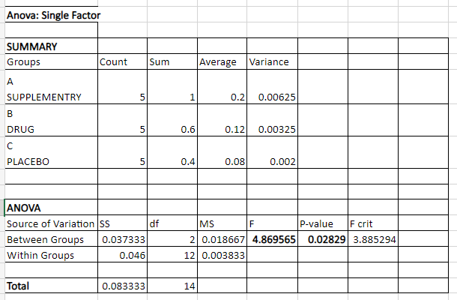

**CONCLUSION:** Since, p value < 0.05 at 5% α. Therefore, we reject H0 and conclude that at least on group of women have different mean, i.e., µ1 ≠ µ2 ≠ µ3.

In order to find which group among A, B and C have significantly different mean we will perform Multiple Comparison (POST HOE TEST)

**STUDENT NEWMAN-KEULS TEST (SNK TEST)**

Q1 = (mean A – mean C) / Sqrt ((MSE /2) *(1/nA-1/nC) = **4.333890711**

Q2 = (mean B – mean C) / Sqrt ((MSE /2) *(1/nB-1/nC) = **2.889260474**

Q3 = (mean A – mean B) / Sqrt ((MSE /2) *(1/nA-1/nB) = **1.444630237**

**STANDARD STUDENT RANGE TABLE (AT ALPHA = 0.5)**

p = 3, q' = **3.77**

p = 2, q' = **3.08**

**CONCLUSION:**Based upon given data we have concluded that gain in weight in malnourished children who received supplementary diet was significantly larger than in those received placebo on an average. However, differences observed in gain in weight between thosewho received supplementary diet and drug or between those who received drug and placebo were not significantly classify.

**PRACTICAL 14**

**QUESTION:**Marks obtain by 10 students in Mathematics and Statistics are given in table.

**DATASET:**

|  |  |
| --- | --- |
| **SCORESIN  MATHEMATICS** | **SCORES IN  STATISTICS** |
| 75 | 85 |
| 30 | 45 |
| 60 | 54 |
| 80 | 91 |
| 53 | 58 |
| 35 | 63 |
| 15 | 35 |
| 40 | 43 |
| 38 | 45 |
| 48 | 44 |

Is there any correlation between Mathematics and Statistics. If yes, how scores in Mathematics effect scores in Statistics.

**OBJECTIVE:** To find is there any correlation association between scores in Mathematics and scores in Statistics.

**FORMULA USED:**

1. CORREL()
2. HOME > ADD INS > TOOL PAK >LINEAR REGRESSION.

**PROCEDURE:**

1. Compute correlation between scores in Mathematics and Statistics using above mentioned function,
2. If correlation exits between the two, we will calculate the regression equation.
3. For that, in Linear Regression toolpak put scores in Statistics in Y input range and scores in Mathematics in X input range,
4. Click OK.

**RESULT:**

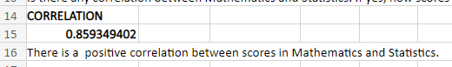

The result states that there is a high positive correlation between the scores in Mathematics and scores in Statistics, i.e., increase in scores in Mathematics increase the scores in Statistics.

Therefore, we will calculate how scores in Mathematics effect scores in Statistics.

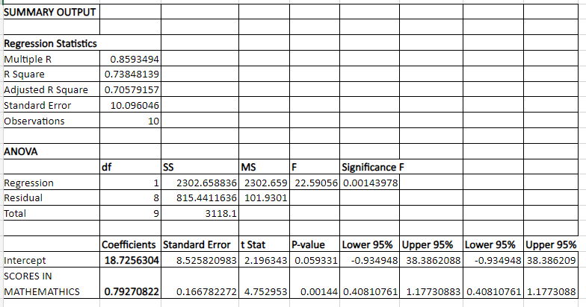

**CONCLUSION:**Y(STATISTICS) = 18.726 + 0.793X (MATHEMATICS)

The regression equation states that unit change in scores in Mathematics gives on an average 0.8 unit change in scores in Statistics.

**PRACTICAL 15**

**QUESTION:**Information on weight, height and age of 12 children are given as follows.

**DATASET:**

|  |  |  |  |
| --- | --- | --- | --- |
| **SERIAL NO.** | **WEIGHT (Kg)** | **HEIGHT (cm)** | **AGE (Months)** |
| 1 | 6.4 | 57 | 8 |
| 2 | 7.1 | 59 | 10 |
| 3 | 5.3 | 49 | 6 |
| 4 | 6.7 | 62 | 11 |
| 5 | 5.5 | 51 | 8 |
| 6 | 5.8 | 50 | 7 |
| 7 | 7.7 | 55 | 10 |
| 8 | 5.7 | 48 | 9 |
| 9 | 5.6 | 42 | 10 |
| 10 | 5.1 | 42 | 6 |
| 11 | 7.6 | 61 | 12 |
| 12 | 6.8 | 57 | 9 |

1. Is there any correlation between Weight and Height?
2. Is there is any correlation between Weight and Age?
3. Perform Simple Linear Regression to predict Weight of children.
4. How Height and Age effects the Weight of children?
5. **OBJECTIVE:** Tofind the correlation association between Weight (Kg) and Height (cm).

**FORMULA USED:**CORREL ()

**PROCEDURE:**Compute correlation between Weightand Height using mentioned function.

**RESULT:**



**CONCLUSION:**

The result states that there is a high positive correlation between the Weight and Height of the children i, e. increase in Weight leads to increase in Height of the children as well.

1. **OBJECTIVE:** To find the correlation association between Weight (Kg) and Age (Months)

**FORMULA USED:** CORREL ()

**PROCEDURE:** Compute correlation between Weightand Age using mentioned function.

**RESULT:**



**CONCLUSION:**

The result states that there is a high positive correlation between the Weight and Age of the children i, e. increase in Weight leads to increase in Age of the children as well.

1. **OBJECTIVE:** To Perform Simple Linear Regression to predict Weight of children.

**FORMULA USED:**HOME > ADD INS > TOOL PAK > LINEAR REGRESSION.

**PROCEDURE:**

1. In Linear Regression toolpak put Weight in input range of Y and Height in input range X to find the Regression Analysis between Weight and Height.
2. Click on OK.
3. Again, put Weight in input range of Y and Age in input range X to find the Regression Analysis between Weight and Age.
4. Click on OK.

**RESULT:**

**LINEAR REGRESSION BETWEEN WEIGHT (KG) AND HEIGHT (CM)**

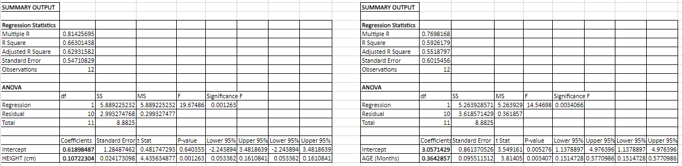

**LINEAR REGRESSION BETWEEN WEIGHT (KG) AND AGE (MONTHS)**



**CONCLUSION:**

* Y (Weight) = 0.62 +0.107 X (Height)

The regression equation states that unit change Weight (Kg) gives on an average 0.364 unit change in Height (cm).

* Y (Weight) = 3.05 + 0.364 X (Months)

The regression equation states that unit change Weight (Kg) gives on an average 0.364 unit change in Age (Months).

1. **OBJECTIVE:**Compute Multiple Regression to find out how Height and Age effects the Weight of children.

**FORMULA USED:** LINEST FUNCTION

**PROCEDURE:**

1. Write the LINEST function and select weight column in known_y's as dependent variable.
2. Also, select both Height and Age column in known_x's independent variable.
3. In const cell, write TRUE as it is a logical value that specifies whether the intercept should be forced to zero. If set to TRUE, the intercept is calculated normally.
4. In stats cell, write TRUEas it is also a logical value that specifies what statistical values to return.

**RESULT:**

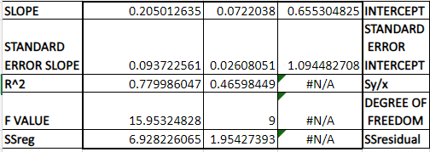

**CONCLUSION:**Y (Weight) = 0.205 +0.072 X1 (Height) +0.655 X2 (Age)

The regression equation states that unit change Weight (Kg) gives on an average 0.072 unit change in Height (cm) and 0.655 unit change in Age (Months).

**PRACTICAL 16**

**QUESTION:**Generate two random samples of size 100 each from normal distribution with mean = 10 and variance = 4, mean = 12 and variance = 5. Also, test if there is any significant difference in mean of two such samples.

**OBJECTIVE:** To generate two random samples of size 100 each from Normal Distribution with mean = 10 and variance = 4, mean = 12 and variance = 5 such that

H0: There is no significance difference between means of 2 samples.

H1: There is a significance difference between means of 2 samples.

**FORMULA USED:**

1. NORM.INV (RAND (), (), ())
2. HOME > ADD INS > TOOL PAK > ANOVA: SINGLE FACTOR.

**PROCEDURE:**

1. Use the above-mentioned function to generate 2 random sample with mean = 10 and standard deviation = 2, mean = 12 and standard deviation = √5 respectively.
2. Drag both the samples till 100th cell to obtain sample of size 100.
3. Set up the Null Hypothesis H0.
4. Set up the Alternative Hypothesis H1.
5. Choose the level of significance (α) or p value at 5%.
6. Compute z statistics using z table.
7. If z calculated < z tabulated value, accept H0 otherwise reject H0.

OR, if p value > 0.05, accept H0 otherwise reject.

**RESULT:**

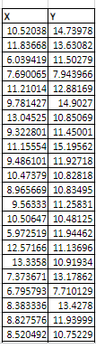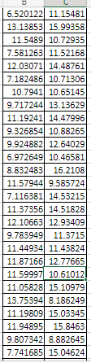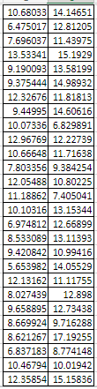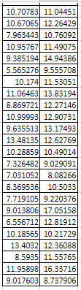

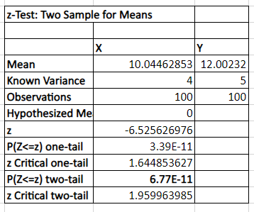

**CONCLUSION:** Since, p value (6.77E-11) < 0.05 at 5% α. Therefore, we reject H0 and conclude that there is a significant difference between the means of two samples.

**PRACTICAL 17**

**QUESTION:**Given the dataset in the workbook Virtual_ Excel_ Test in the sheet Level 1, using excel formula mention the Company’s name against the Employee ID.

**DATASET:**

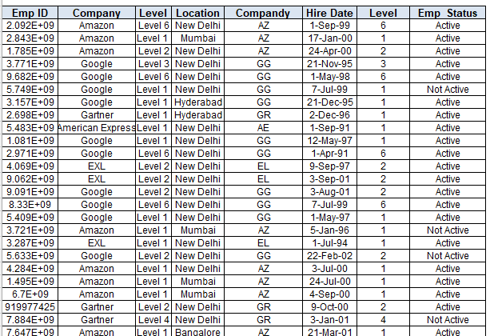

LINK:

<https://docs.google.com/spreadsheets/d/1Ev8jHQ3q3NQrrhbOKDccHgSU95Z0kaavRWFhvDeS2sA/edit?usp=sharing>

**OBJECTIVE:** To mention the Company’s name against each Employee ID from the dataset.

**FUNCTION USED:** VLOOKUPSTATEMENT

**PROCEDURE:**

1. Apply the VLOOKUP function and select the cell containing Employee ID.
2. Select the whole dataset from the sheet Data.
3. Write the column number containing the Company name.
4. The required Company name is found for the given Employee ID.
5. Drag down the remaining cells.

**RESULT:**

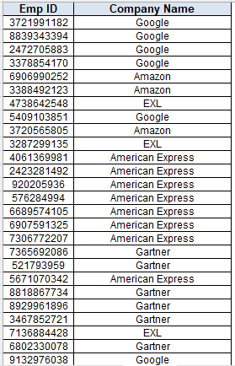

LINK:

<https://docs.google.com/spreadsheets/d/1Ev8jHQ3q3NQrrhbOKDccHgSU95Z0kaavRWFhvDeS2sA/edit?usp=sharing>

**PRACTICAL 18**

**QUESTION:**Given the dataset in the workbook Virtual_ Excel­ Test in sheet Level 2, populate column B with Total number of Employees for each Company from base data using excel functions.

**DATASET:**



LINK:

<https://docs.google.com/spreadsheets/d/1Ev8jHQ3q3NQrrhbOKDccHgSU95Z0kaavRWFhvDeS2sA/edit?usp=sharing>

**OBJECTIVE:** To fill column B with Total number of Employees from the base data.

**FUNCTION USED:** COUNTIFSTATEMENT

**PROCEDURE:**

1. Use the COUNTIF function and select the whole dataset from the datasheet.
2. Select the cell containing the Company name.
3. The number of Employees is obtained for that Company.
4. Drag down the remaining cells.

RESULT:

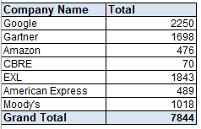

**PRACTICAL 19**

**QUESTION:**Given the dataset in the workbook Virtual_ Excel_ Test in Level 3 excel sheet, populate column B to L with Total number of Employees for each Company and Location from base data using “COUNTIFS” function.

**DATASET:**



LINK:

<https://docs.google.com/spreadsheets/d/1Ev8jHQ3q3NQrrhbOKDccHgSU95Z0kaavRWFhvDeS2sA/edit?usp=sharing>

**OBJECTIVE:** To fill column B to L with the Total number of Employees for each Company and their respective Locations.

**FUNCTION USED:** COUNTIFSSTATEMENT

**PROCEDURE:**

1. Use the COUNTIFS function and select the Company name data from the sheet Data.
2. Select the cell containing the company name.
3. Select the Location data from the sheet Data.
4. Select the cell containing the location with absolute reference i.e., using the $ sign.
5. Required result is obtained. Drag down the remaining cells.
6. Repeat the same procedure for the remaining columns having different Locations.

**RESULT:**

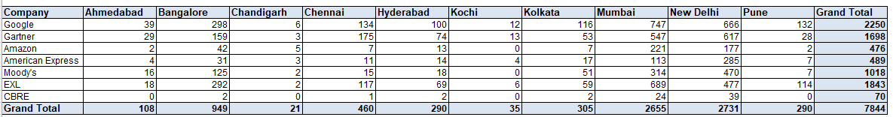

**PRACTICAL 20**

**QUESTION:** Given the dataset in the workbook Virtual_ Excel_ Test

1. in Level 4 sheet of excel, calculate percentage of on contracts in column E.
2. Populate column F if percentage of on contracts exceed 5 % then “OK” else “NOT OK” using excel function.

**DATASET:**



LINK:

<https://docs.google.com/spreadsheets/d/1Ev8jHQ3q3NQrrhbOKDccHgSU95Z0kaavRWFhvDeS2sA/edit?usp=sharing>

**OBJECTIVE:**

1. To calculate the percentage of ‘On Contracts’ and fill column E.
2. Find the status whether the percentage is greater than 5% or not.

**FUNCTION USED:** IF STATEMENT

**PROCEDURE:**

1. Use the formula (on contacts/ grand total) *100% to calculate the percentage for corresponding cell.
2. Drag down the remaining cells.
3. Use the IF function to find the status.
4. Select the on contracts cell, write the first condition “OK” and the other condition as “NOT OK”.
5. Drag down the remaining cells.

**RESULT:**

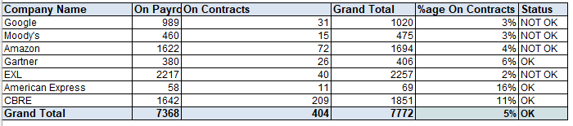

**PRACTICAL 21**

**QUESTION:** Given the dataset in the workbook Virtual_ Excel _Test in excel sheet Level 5 using conditional formatting do the following:

1. Red highlight cells with average work experience of less than equal to 2 years.
2. Yellow highlight cells with average work experience between 2 to 3 years.
3. Green highlight cells with average work experience of greater than 3 years.

**DATASET:**



LINK:

<https://docs.google.com/spreadsheets/d/1Ev8jHQ3q3NQrrhbOKDccHgSU95Z0kaavRWFhvDeS2sA/edit?usp=sharing>

**OBJECTIVE:** To perform conditional formatting on the given dataset.

**FUNCTION USED:** CONDITIONAL FORMATTING

**PROCEDURE:**

1. Select the dataset to apply conditional formatting.
2. Apply the first rule less than 2 and select the red colour to highlight.
3. Apply the second rule between 2 and 3 and select the yellow colour to highlight.
4. Apply the third rule greater than 3 and select the green colour to highlight the cell.

**RESULT:**

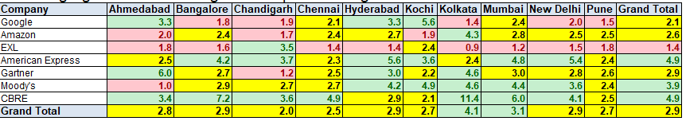

**PRACTICAL 22**

**QUESTION:** Use Virtual_ Excel_ Test workbook in Level 6 do the following:

1. Populate Column D as "Completed" if Soft Skills hours (Col B) is greater than or Equal to 10 otherwise "Not Completed".
2. Populate Column E as "Completed" If Technical hours (Col C) is greater than or Equal to 20 otherwise "Not Completed".
3. Populate Column F as "Completed" if both Column D & E is Completed otherwise “Not Completed”.
4. Column D, E, F should say "Not Applicable" wherever Column D or E is "NA"

**DATASET:**



LINK:

<https://docs.google.com/spreadsheets/d/1Ev8jHQ3q3NQrrhbOKDccHgSU95Z0kaavRWFhvDeS2sA/edit?usp=sharing>

**OBJECTIVE:**To perform various tasks such as:

1. Populate Column D as "Completed" if Soft Skills hours (Col B) is greater than or Equal to 10 otherwise "Not Completed".
2. Populate Column E as "Completed" If Technical hours (Col C) is greater than or Equal to 20 otherwise "Not Completed".
3. Populate Column F as "Completed" if both Column D & E is Completed otherwise “Not Completed”.
4. Column D, E, F should say "Not Applicable" wherever Column D or E is "NA".

**FUNCTION USED:**

* + - 1. IF STATEMENT
      2. IFS STATEMENT

**PROCEDURE:**

1. Using IF statement to populate Column D as "Completed" if Soft Skills hours (Col B) is greater than or Equal to 10 otherwise "Not Completed".
2. Using IFS statement to populate Column E as "Completed" If Technical hours (Col C) is greater than or Equal to 20 otherwise "Not Completed".
3. Using IF statement to populate Column F as "Completed" if both Column D & E is Completed otherwise “Not Completed”.
4. Column D, E, F should say "Not Applicable" wherever Column D or E is "NA".

**RESULT:**

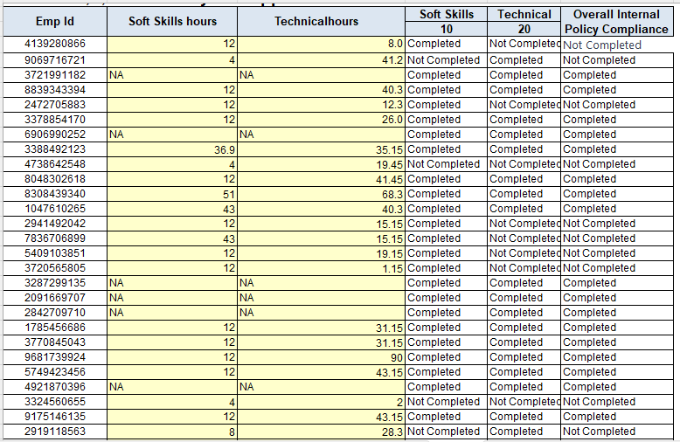

LINK:

<https://docs.google.com/spreadsheets/d/1Ev8jHQ3q3NQrrhbOKDccHgSU95Z0kaavRWFhvDeS2sA/edit?usp=sharing>

**PRACTICAL 23**

**QUESTION:** Using Virtual_ Excel_ Test workbook create a pivot table o base sheet and provide the following data:

1. Total number of employees in each location by level also format reports to look professional.

**DATASET:**



LINK:

<https://docs.google.com/spreadsheets/d/1Ev8jHQ3q3NQrrhbOKDccHgSU95Z0kaavRWFhvDeS2sA/edit?usp=sharing>

**OBJECTIVE:** To create a pivot table to represent total number of employees in each location by level.

**FUNCTION USED:** INSERT > PIVOT TABLE

**PROCEDURE:**

Go to insert and click on pivot table.

Drag Location variable in Rows box.

Drag Levels variable in Columns box.

Drag Emp ID variable in Values box and change the value field as Count of Emp ID.

Click on ok.

**RESULT:**

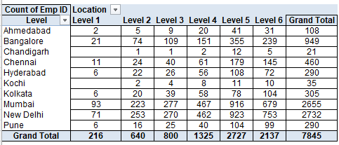

**PRACTICAL 24**

**QUESTION:** Using Virtual_ Excel_ Test workbook Level 8 to populate column C and D from Data sheet to get the count of Active and Not Active against their respective levels.

**DATASET:**



LINK:

<https://docs.google.com/spreadsheets/d/1Ev8jHQ3q3NQrrhbOKDccHgSU95Z0kaavRWFhvDeS2sA/edit?usp=sharing>

**OBJECTIVE:** To get the count of Active and Not Active against their respective levels.

**FUNCTION USED:** COUNTIFSSTATEMENT

**PROCEDURE:**

1. Use the COUNTIFS function and select the Level data from the Data sheet.
2. Select the cell containing the Level.
3. Select the Employee Status data from the Data sheet.
4. Select the cell under the column name Active using absolute reference.
5. The required result is obtained and drag down the remaining cells.
6. Repeat the same procedure for Not Active column.

**RESULT:**

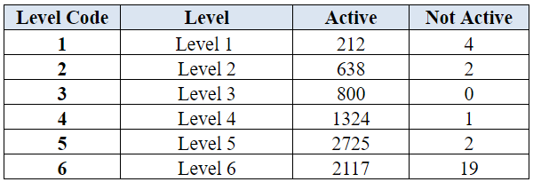

**PRACTICAL 25**

**QUESTION:**Use Virtual_ Excel_ Test workbook to calculate experience in years as of June 1, 2017.

**DATASET:**



LINK:

<https://docs.google.com/spreadsheets/d/1Ev8jHQ3q3NQrrhbOKDccHgSU95Z0kaavRWFhvDeS2sA/edit?usp=sharing>

**OBJECTIVE:** To calculate the experience in years of the employees as of June 1, 2017.

**FUNCTION USED:** DATEDIFSTATEMENT

**PROCEDURE:**

1. Use the DATEDIF function and select the date of joining against the respective employee id.
2. Using the DATE function enter the date June 1, 2017.
3. Enter “Y” to get the result in years.
4. The required result is obtained.

**RESULT:**

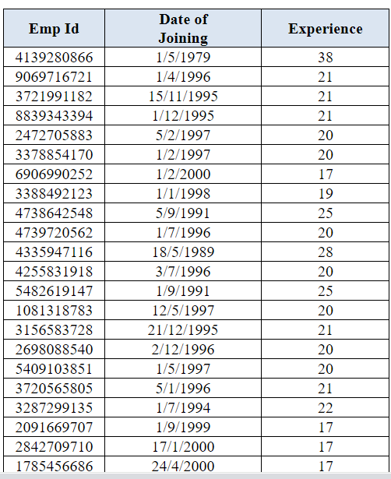

**PRACTICAL 26**

**QUESTION:** Based on the given constraints and objective function, obtain the value of P and Q such a way that it will maximise the objective function 45x + 60y – 6000 subjected to the constraints:

15x + 10y <= 2400

15x +15y +15y <= 2400

10x +5x +5y <= 2400

15x +15y <= 2400

x <= 100

y <= 50

x,y >= 0

x,y should be integers

**OBJECTIVE:** To maximise the objective function based on given information.

**FORMULA USED:** DATA > SOLVER

**PROCEDURE:**

1. Enter the values 0 for both variables whose value we need to compute (in yellow colour).
2. Write the maximising objective function (in purple colour).
3. Writ all the constraints as mentioned (in pink colour).
4. Go to Solver and:
5. Specify Objective Cell (objective function).
6. Specify Changing Cells (decision variables).
7. Specify Constraints with respective signs.
8. Specify Solver Settings (Simplex LP) and (GRE Nonlinear).
9. Solve Problem to find Optimal Solution.

**RESULT:**

**BY SIMPLEX METHOD**

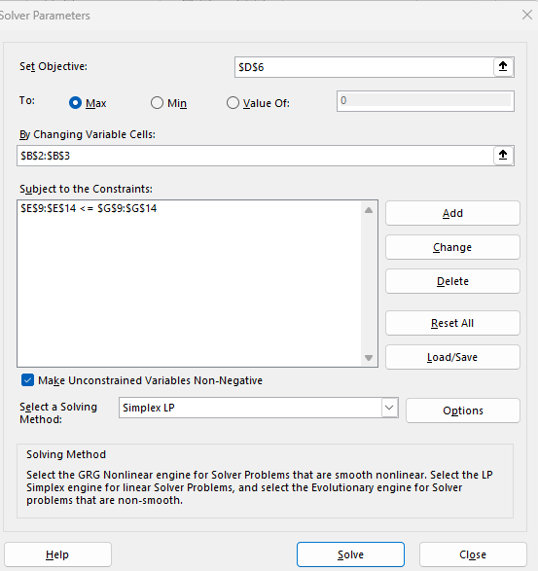

**BY NONLINEAR METHOD**

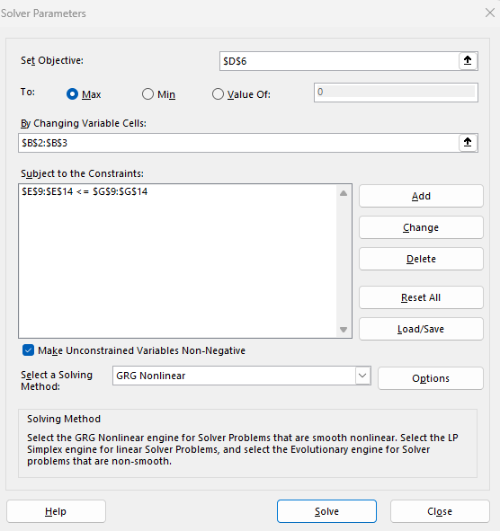

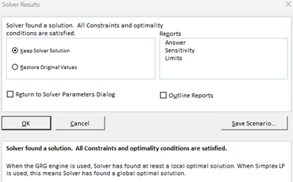

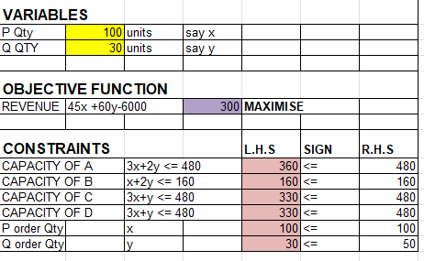

**CONCLUSION:**

P Qty (x) = 100 units

Q Qty (y) = 30 units

And Maximize Revenue = Rs 300

**PRACTICAL 27**

**QUESTION:**Consider the function f(x) = x4 + 8x2 -3. Use MS -Excel to find the value of x that minimises the function f.

**OBJECTIVE:** To minimise the objective function of given f(x).

**FORMULA USED:** DATA > SOLVER

**PROCEDURE:**

1. Enter the values 0 forvariable xwhose value we need to compute (in orange colour).
2. Write the minimising objective function as f(x) (in purple colour).
3. Go to Solver and:
4. Specify Objective Cell (objective function).
5. Specify Changing Cells (decision variables).
6. Specify Solver Settings (GRG Nonlinear).
7. Solve Problem to find Optimal Solution.

**RESULT:**

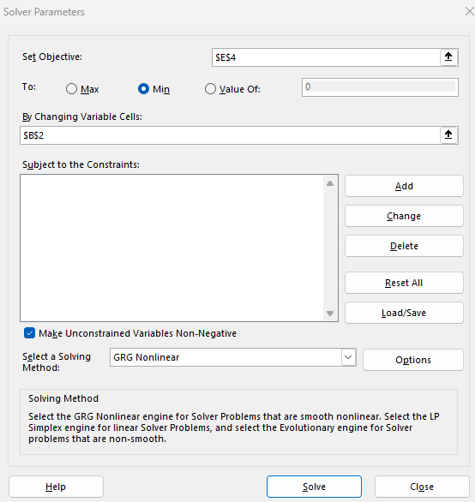

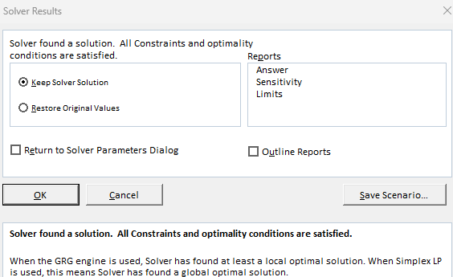

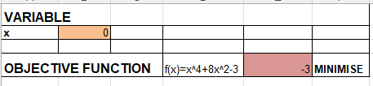

**CONCLUSION:**

The function f(x) = x4 + 8x2 -3 is thus minimised by the value x = 0.

**PRACTICAL 28**

**QUESTION:** With exactly 2700 cm2 of cardboard, we wish to construct a box (width x, depth y and height z) that can contain a VolumeV. We require the width to be double its depth. We would like to maximize the volume the box can hold. Which values of x, y, z fulfils our objective.

**OBJECTIVE:** To maximizing the box volume expressed as V (x, y, z) = x*y*z.

**FORMULA USED:** DATA > SOLVER

**PROCEDURE:**

1. First, identify the variables, define the objectives and the constraints.
2. Enter the values 0 for all 3 variables whose value we need to compute (in yellow colour).
3. Write the maximising objective function (in blue colour).
4. Writ all the constraints as mentioned (in pink colour).
5. Go to Solver and:
6. Specify Objective Cell (objective function).
7. Specify Changing Cells (decision variables).
8. Specify Solver Settings (GRG Nonlinear).
9. Solve Problem to find Optimal Solution.

**RESULT:**

Let x, y, z be the width, depth and height of the cardboard box.

Objective Function:

Maximize V (x, y, z) = x*y*z

Subject To:

2xy+2yz+2xz = 2700

x = 2y

x, y, z > 0

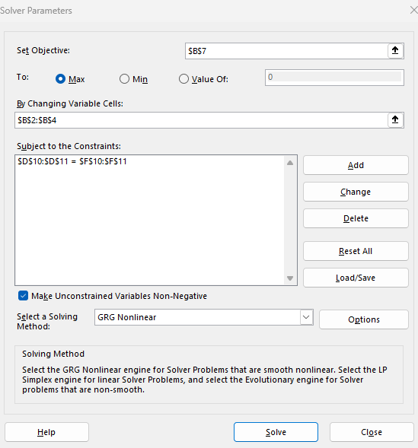

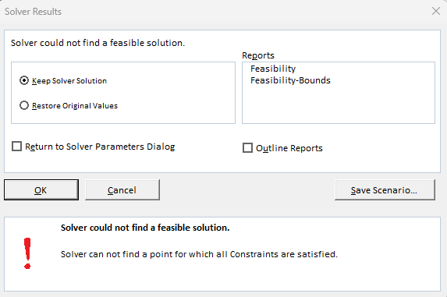

This can occur if the variables are initially on a **fixed point** of the objective function that does not satisfy the requested criteria (maximum).

In this problem, if the cells of variables x, y, z are empty before questioning the Solver, they take on the value 0 by default. Therefore, we get the message of error. To fix the situation, we need to modify the initial values of the variables.For example, by giving the variables x, y, z as the values 1, 1, and 1, then the Solver will return the following solution:

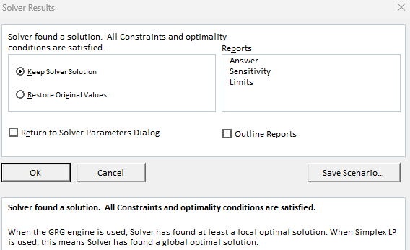

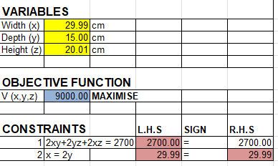

**CONCLUSION:**

Width (x) = 30 cm

Depth (y) = 15 com

Height (z) = 20 cm

And Volume = 9000 cm3

PRACTICAL 29

**QUESTION:** Create a database and label it as "Library DB". Also add "Borrow _Dataset" and "Inventory _Master" after creating this database

1. Count the number of rows in both the tables.
2. To check the variable names or field names and to get an idea of the data view top 10 rows of each table.

**OBJECTIVE:** To create a database named “LibraryDB” and do the following:

1. To count the number of rows in table, “Borrow _Dataset” and “Inventory _Master".
2. To check the variable names or field names and to get an idea of the data view top 10 rows of each table.

**SOFTWARE USED:**MICROSOFT SQL SERVER MANAGEMENT STUDIO

**PROCEDURE:**

1. Open SQL Server Management Studio.
2. Right-click on Database’ >New Database>Enter Name “LibraryDB”.
3. Right-click on “LibraryDB” >Task >Import Flat File >”Borrow_Dataset”.
4. Right-click on “LibraryDB” >Task >Import flat file >”Inventory_Master”.
5. Refresh the database.
6. Use ‘count’ function to know the number of rows for each table.
7. Use ‘top 10’ function to know field names and to get an idea of the data view top 10 rows of each table.

**RESULT:**

1. **CODE:**



**OUTPUT:**



**CODE:**

  
**OUTPUT:**

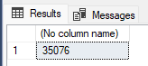

1. **CODE:**



**OUTPUT:**

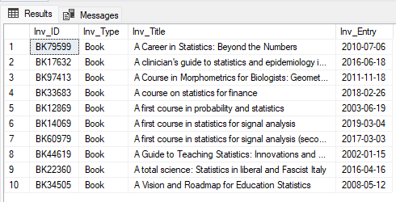

**CODE:**



**OUTPUT:**

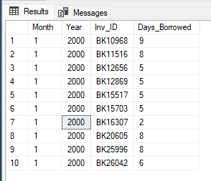

PRACTICAL 30

**QUESTION:** Use LibraryDB database and do the following.

1. The Administration wants to know the type of inventory maintained by the library and its count. Summarize it at one table.
2. Filter the dataset for inventory type as Book and inventory entry date greater than

2020-01-01.

**OBJECTIVE:**To use LibraryDB database and do the following.

1. To know the type of inventory maintained by the library and its count.
2. To filter the dataset for inventory type as Book and inventory entry date greater than 2020-01-01.

**SOFTWARE USED:**MICROSOFT SQL SERVER MANAGEMENT STUDIO

**PROCEDURE:**

1. Open the SQL Server Management Studio.
2. Use the ‘count’ function to know the type of inventory maintained by the library and its count.
3. Use the ‘from’ and ‘where’ function to filter the dataset for inventory type as Book and inventory entry date greater than 2020-01-01.

**RESULT:**

1. **CODE:**

  
**OUTPUT:**

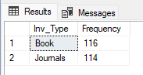

1. **CODE:**



**OUTPUT:**

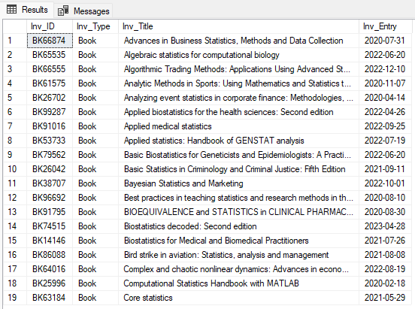

**PRACTICAL 31**

**QUESTION:** Library administration wants to know the details of “Borrow_Dataset” along with inventory type, title and entry data as one table. Provide this table.

**OBJECTIVE:** To know the details of “Borrow_Dataset” along with inventory type, title and entry data as one table.

**SOFTWARE USED:**MICROSOFT SQL SERVER MANAGEMENT STUDIO.

**PROCEDURE:**

1. Open Microsoft SQL Server Management Studio.
2. Use the function ‘left join’ to know the details of “Borrow_Dataset” along with inventory type, title and entry data as one table.
3. Required table is obtained.

**RESULT:**

**CODE:**



**OUTPUT:**

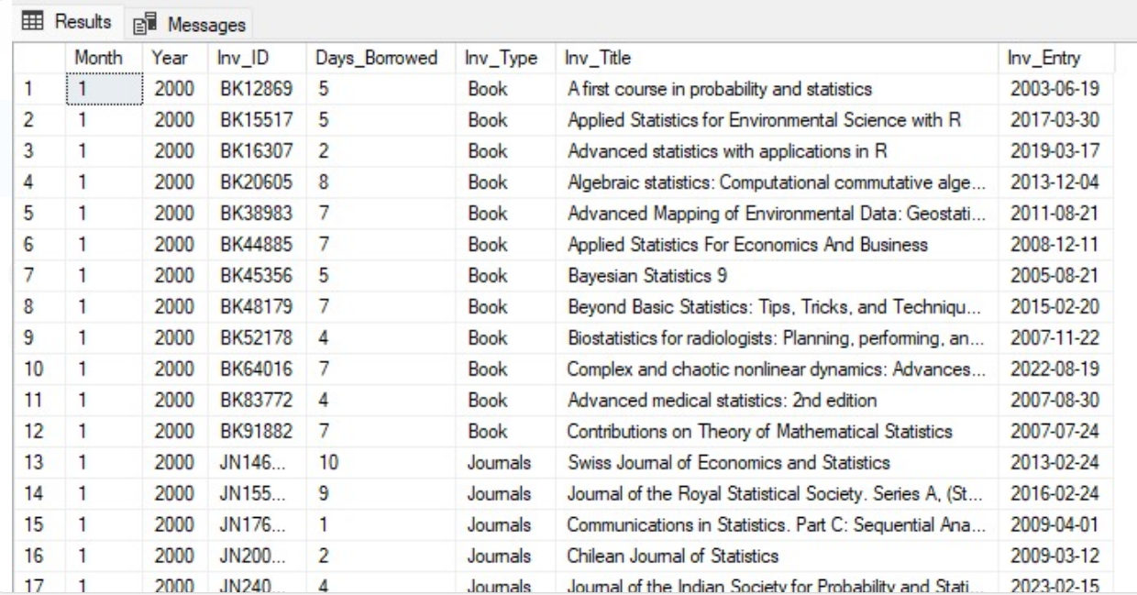

**PRACTICAL 32**

**QUESTION:** Use “LibraryDB” database and answer the following:

1. Report the year wise addition to library.
2. How many books are added each year?
3. How many journals are added each year?
4. How many journals were added after 2002?
5. Which inventory type borrowed most?

**OBJECTIVE:** To use “LibraryDB” database and answer the following:

1. Report the year wise addition to library.
2. To the number of books that are added each year.
3. To know the number of journals added each year.
4. To know the number of journals added after 2002.
5. To know the inventory type borrowed the most.

**SOFTWARE USED:**MICROSOFT SQL SERVER MANAGEMENT STUDIO.

**PROCEDURE:**

1. Open the Microsoft SQL Server Management Studio.
2. Use the function ‘count’ to report the year wise addition to library.
3. Use the functions ‘count’, ‘from’, ‘where’ to know the number of books added each year.
4. Use the functions ‘count’, ‘from’, ‘where’ to know the number of journals added each year.
5. Use the functions ‘from’, ‘where’, ‘group’ to know the number of journals added after year 2002.
6. Use function ‘sum’ to know the inventory type borrowed most.

**RESULT:**

1. **CODE:**

  
**OUTPUT:**

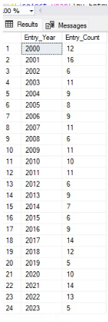

1. **CODE:**

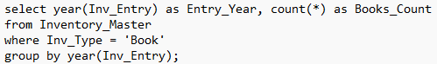  
**OUTPUT:**

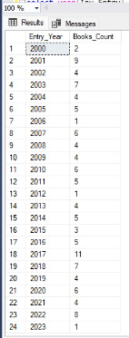

1. **CODE:**

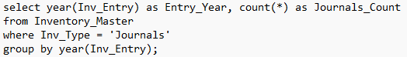  
**OUTPUT:**

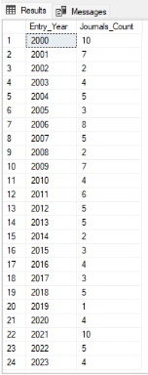

1. **CODE:**

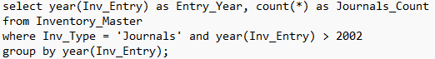  
**OUTPUT:**

  
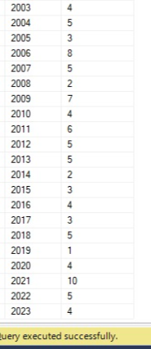

1. **CODE:**

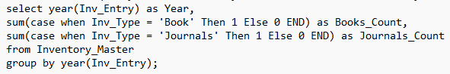  
**OUTPUT:**

